**Top Earner**

We define an employee's total earnings to be their monthly  worked, and the maximum total earnings to be the maximum total earnings for any employee in the **Employee** table. Write a query to find the maximum total earnings for all employees as well as the total number of employees who have maximum total earnings. Then print these values as  space-separated integers.

**Input Format**

The **Employee** table containing employee data for a company is described as follows:

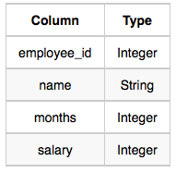

where employee_id is an employee's ID number, name is their name, months is the total number of months they've been working for the company, and salary is the their monthly salary.

**Sample Input**

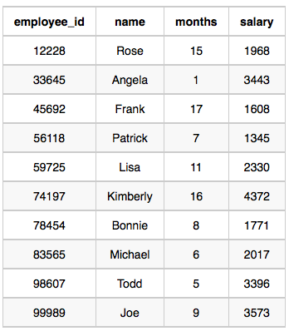

**Sample Output**

69952 1

**Explanation**

The table and earnings data is depicted in the following diagram:

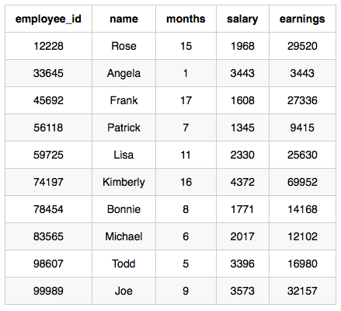

The maximum earnings value is . The only employee with earnings  is Kimberly, so we print the maximum earnings value () and a count of the number of employees who have earned  (which is ) as two space-separated values.

select (salary*months) as tot_earning, count(*) from employee

group by tot_earning

order by tot_earning desc

limit 1;